**Day 1: Market & Creative Strategy**

**TV Product Visual Research & Social Growth Plan (2026)**

**Prepared For:** Internal Review / Brand Leadership **Prepared By:** RAGHAV (Creative Technologist) **Date:** January 12, 2026 **Status:** Confidential

**1. Executive Summary**

This document captures research, observations, and creative explorations conducted on Day 1, focusing on product listing visuals and social media growth opportunities.

Our goal is to define a visual language that respects the constraints of e-commerce platforms while aggressively capturing market share through psychology-driven creative and algorithmic social growth.

**2. Brand Landscape Overview**

To position Coocaa effectively, we analyzed the current landscape to define our creative boundaries.

* **Coocaa:** The Challenger. Youth-focused, energetic, value-driven. Visuals are bold and experimental.
* **Metz:** The Heritage. European legacy, engineering-focused. Visuals are clean and understated.
* **Philips:** The Standard. Globally trusted, technology-first. Visuals are consistent and safe.

**Insight:** While competitors focus on specs or heritage, Coocaa has the unique opportunity to own "personality" and "visual disruption."

**3. E-commerce Listing Reality (Amazon & Flipkart)**

**The Constraint:** All brands must adhere to strict mandatory standards for TV main images. The background, framing, and product placement are rigidly controlled by the platform. This causes a "Sea of Sameness" where all brands appear identical in search results.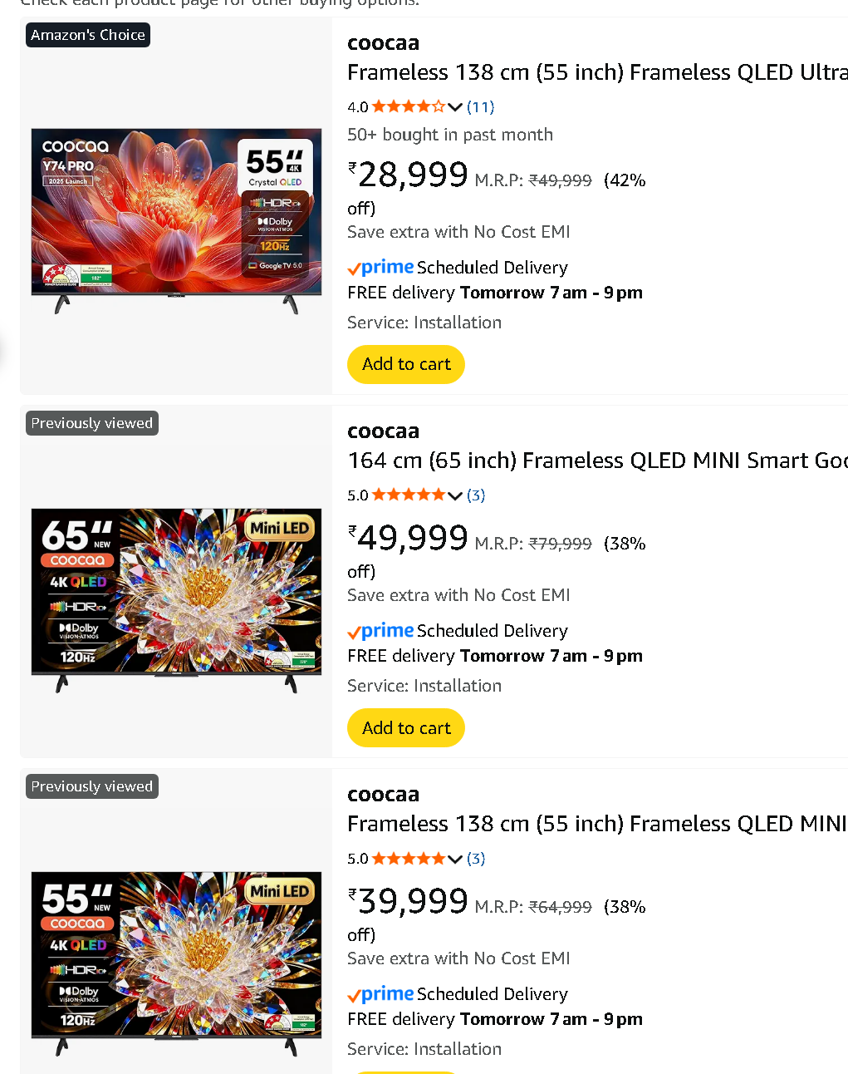

**The Strategic Pivot:**

"Since we cannot change the outer frame of the listing, the only real creative control lies in what we show *inside* the TV screen."

The internal screen space is our key creative battlefield.

**4. Creative Strategy: Main Image Approaches**

We explored three distinct directions to stand out while remaining fully Amazon-compliant.

**Approach 01: High-Definition Psychology (The HD Series)**

*Concept:* Moving beyond generic landscapes to leverage cognitive bias and evolutionary psychology.

* **The Evolutionary Gaze:** Humans are hardwired to look at eyes/faces. A high-fidelity close-up of an eye forces an immediate attention lock.
* **The Zeigarnik Effect (The Gap):** The brain hates ambiguity. Using incomplete textures or macro details forces the viewer's brain to "fill in the gaps," creating a stronger memory imprint.

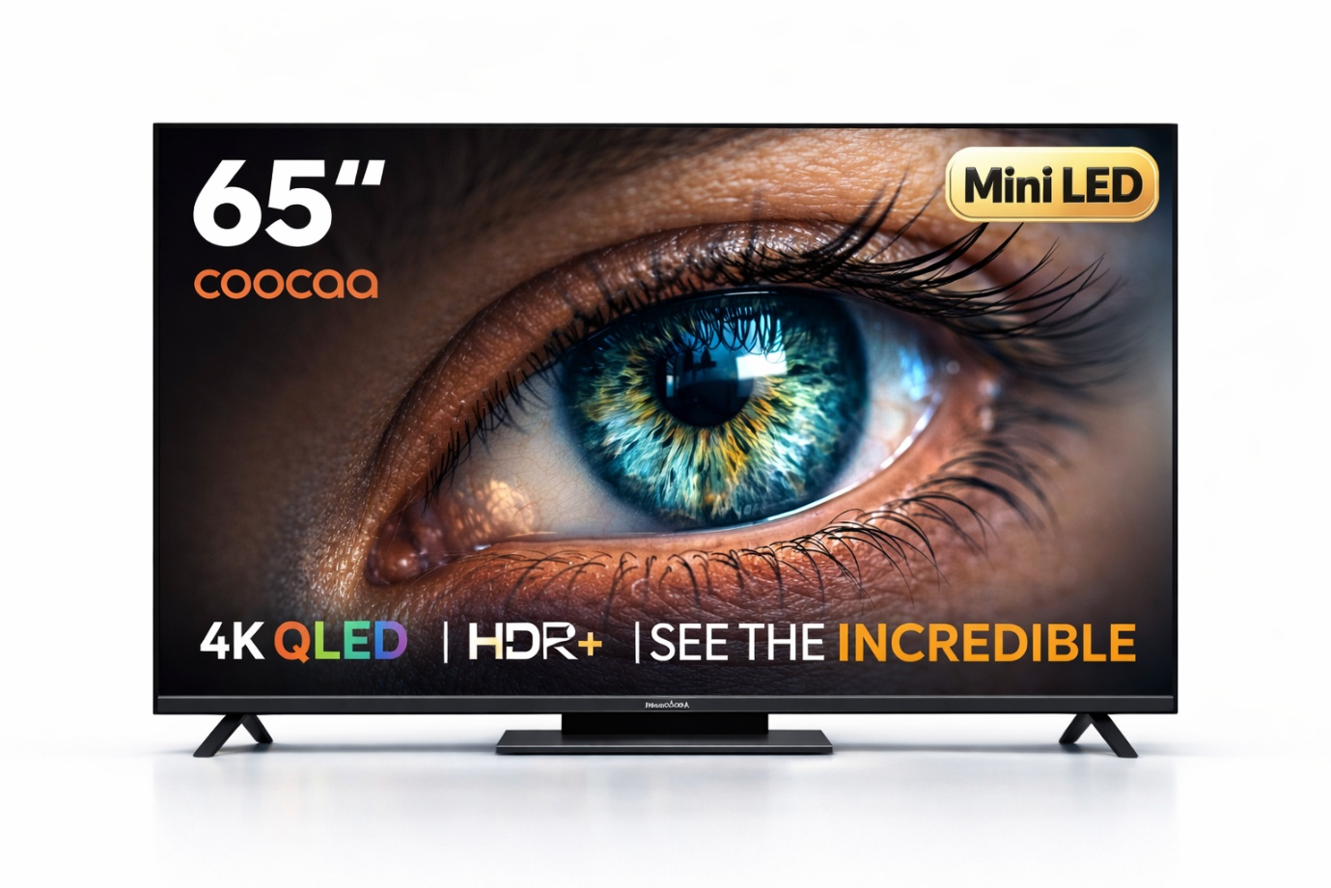 *(Caption: Visual Hook - The Eye)*

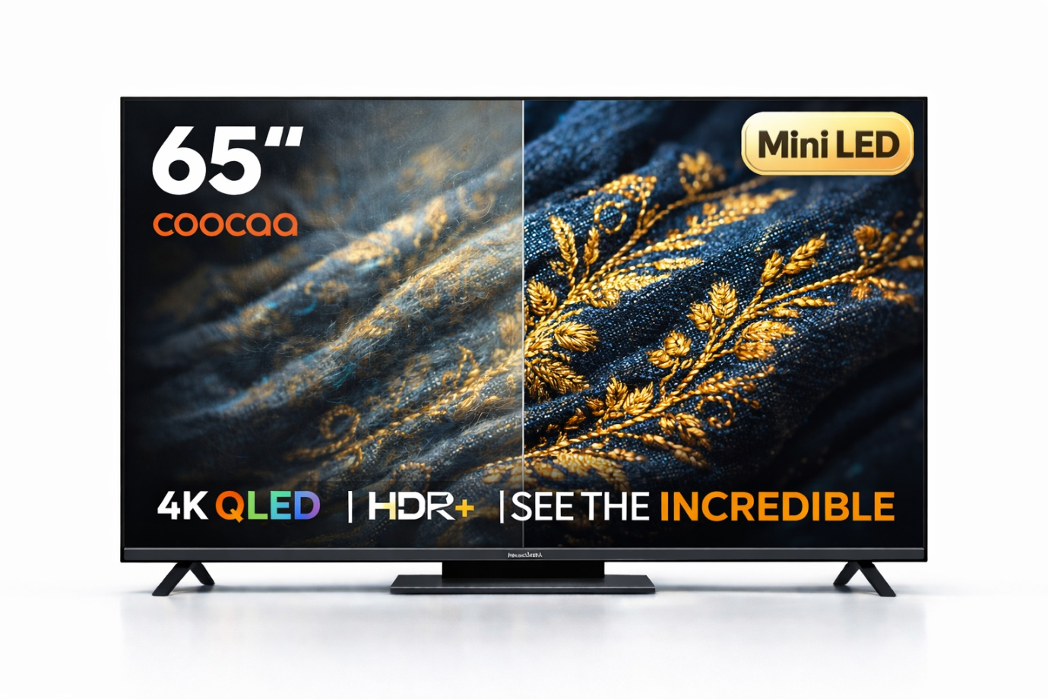 *(Caption: Macro Texture)*

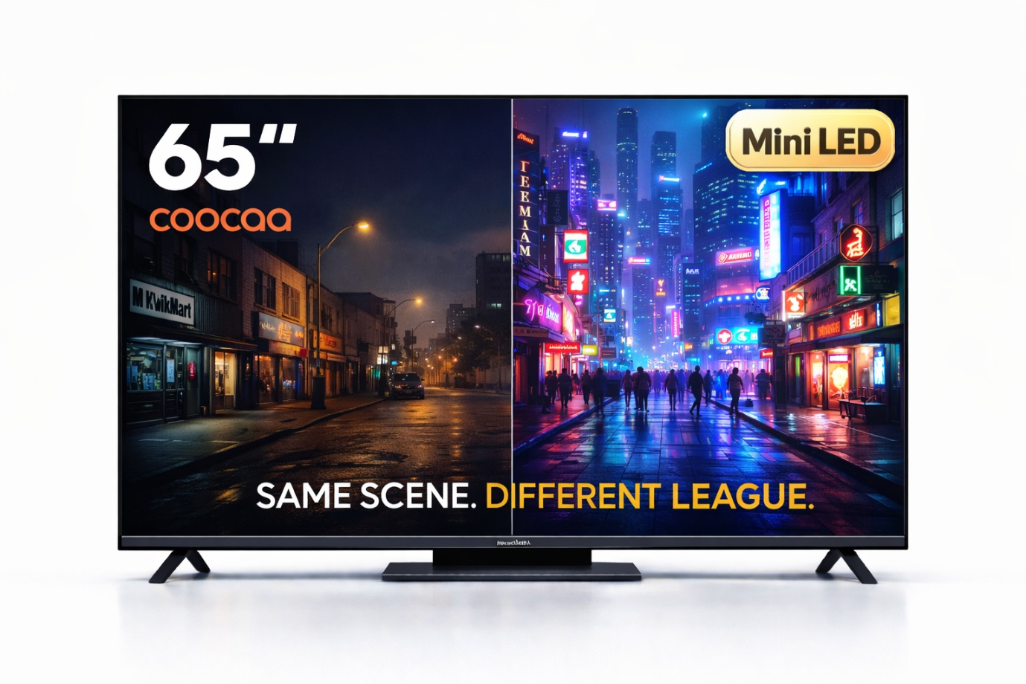 *(Caption: Cognitive Gap)*

**Approach 02: Gen Z Bold Visual Language**

*Concept:* Loud, colorful, and modern art styles. This is a confident risk designed to stop the scroll instantly, speaking directly to a digital-native demographic.

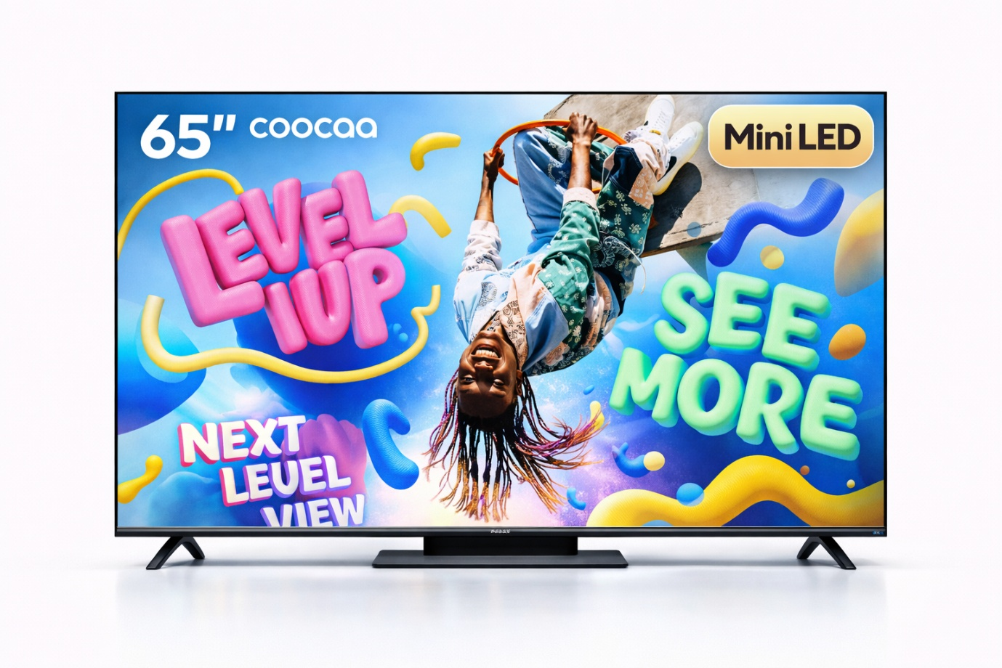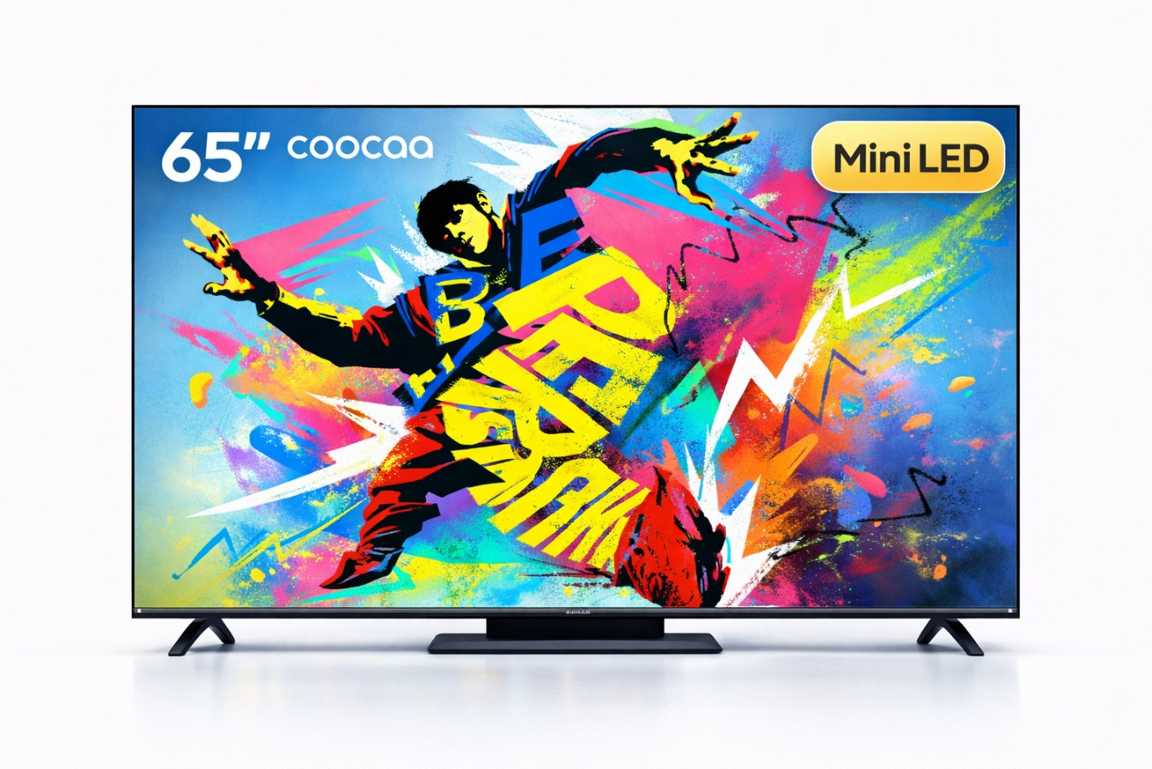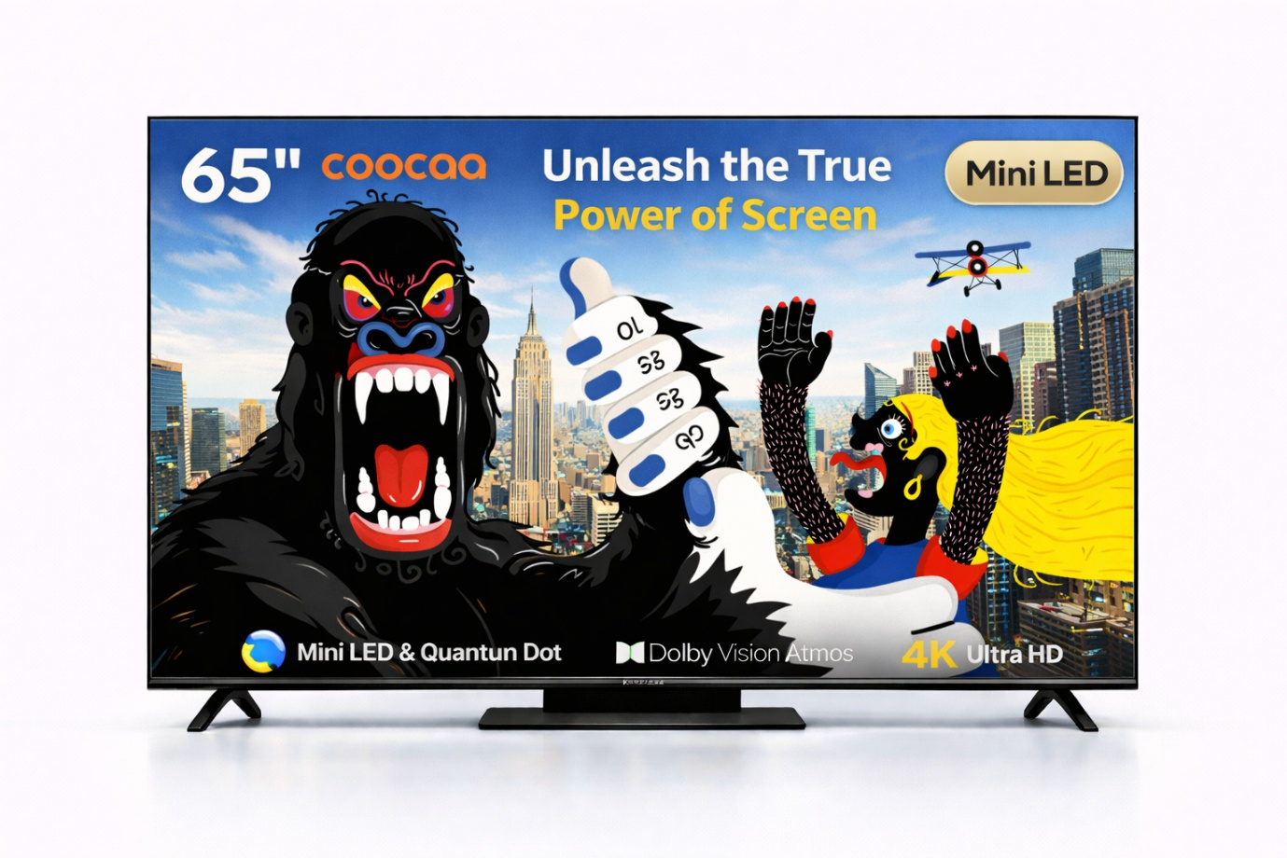**Approach 03: Conceptual Storytelling**

*Concept:* Visual metaphors (e.g., Cat → Tiger) to demonstrate power, clarity, and transformation. We sell the *feeling* of the technology, not just the pixels.

*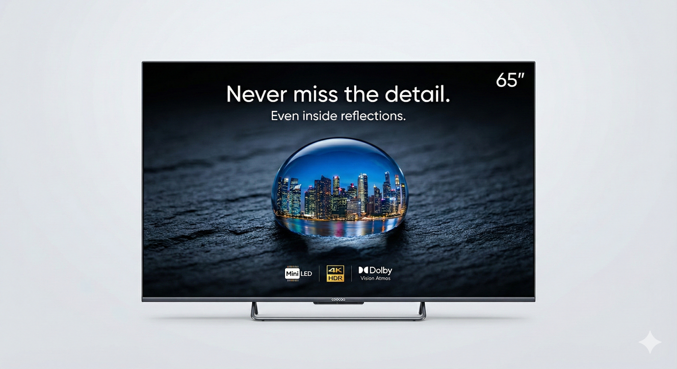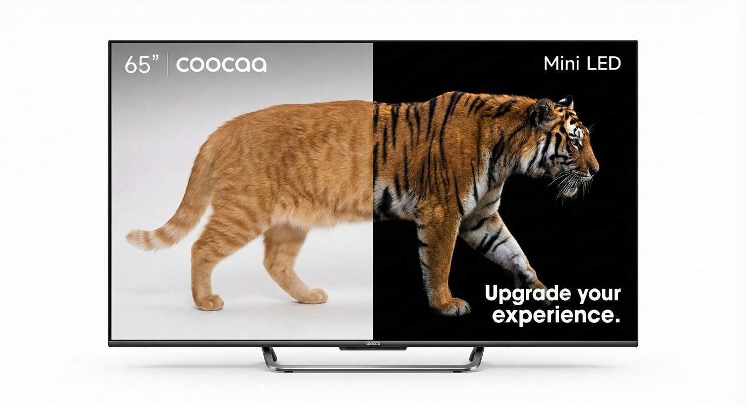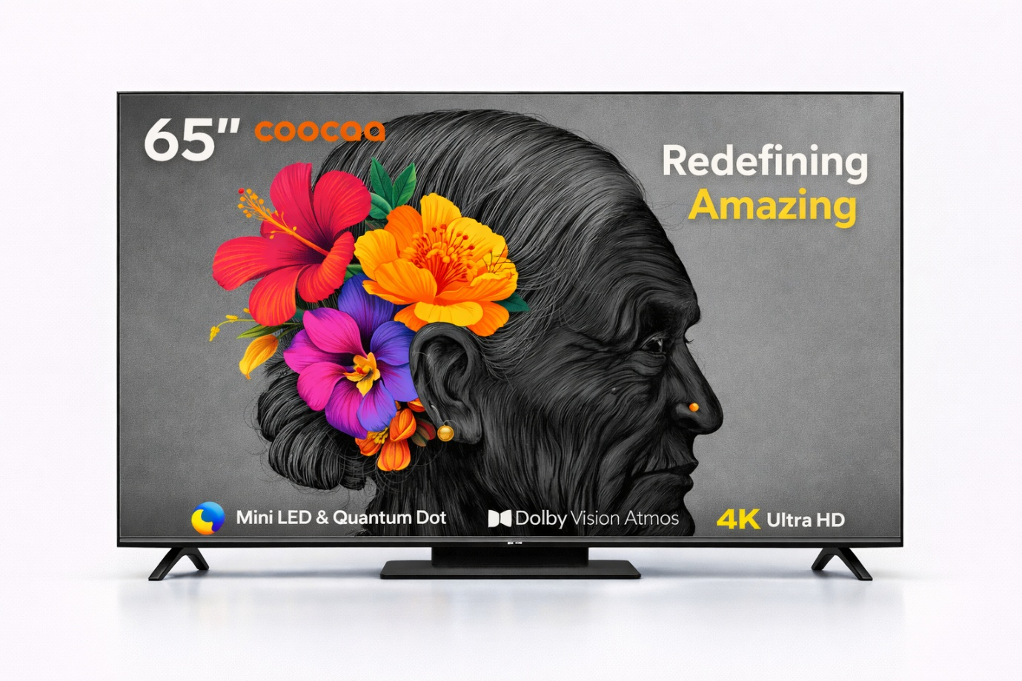> Disclaimer: Visuals are conceptual explorations. Final assets to be professionally rendered.*

**5. Social Media Ecosystem**

**Platform Roles:**

* **Facebook:** Functional support. High reach, older demographic. Good for broad awareness.
* **Instagram:** Brand building. Visual storytelling, younger demographic. This is where brand equity is built.

**Strategic Conclusion:** Facebook supports reach; Instagram builds the cult following.

**6. Instagram Growth Strategy (2026 Roadmap)**

**Goal:** Double Followers in 3 Months.

**A. The Algorithm Decoded**

To win, we must feed the algorithm what it wants:

1. **Recency:** Use trending audio within 48 hours to triple reach.
2. **Retention:** "Watch time is king." If a user loops a Reel, it is flagged as viral quality.
3. **Micro-Interactions:** Saves > Likes. We must create content useful enough to be Saved.

**B. Content Pillars**

1. **Festive & Cultural (Coocaa India):** Own the moment. Example: "The Ultimate Cricket World Cup Setup" or "Colors of Holi in 4K."
2. **Bold & Challenger (Coocaa Global):** Side-by-side comparisons. "Why pay double for the same pixels?"
3. **Humor & Relatable:** "POV: You lost the remote again." Humanize the tech.

**C. Incentivized Growth Mechanics (The "Candy")**

Strategies to force conversion through value exchange:

* **Setup Wars (UGC):** Users post their current "bad" setup. Best/funniest entry wins a TV. (Massive organic reach).
* **The Unlock Challenge:** "If this Reel hits 10k Shares, we unlock a 1-hour flash reward." (Forces viral sharing).
* **Tech Education:** "Stop using these settings on your TV." (High 'Save' count).

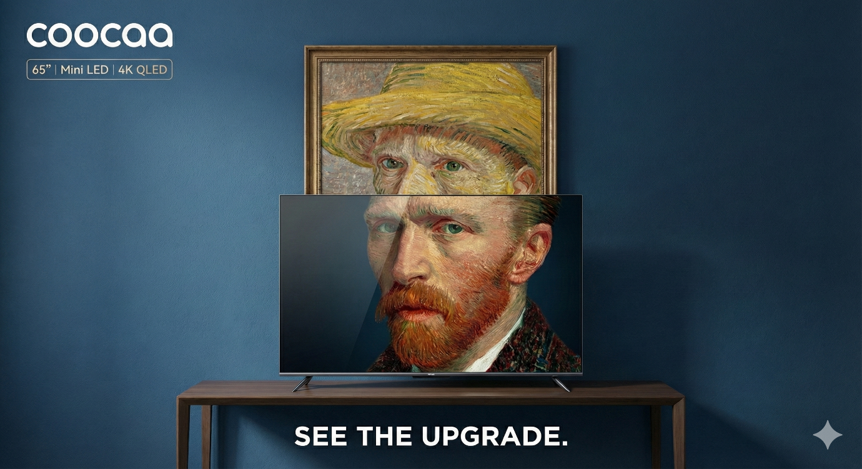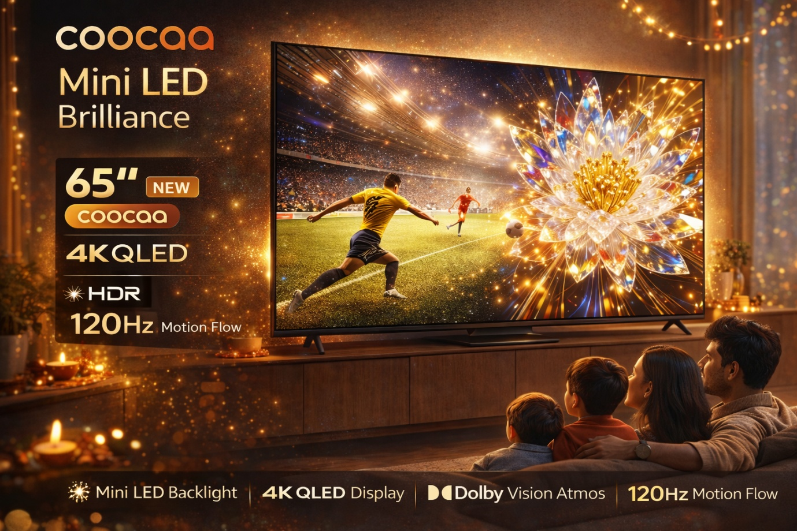

**7. Closing Statement**

"Instead of showing what everyone already sees, this strategy focuses on what people usually overlook — where premium clarity truly matters."

谢谢您的时间与信任。

**© 2026 Strategic Brand Division | Lead Creative: RAGHAV**